Parish of the Durham Martyrs - Heating and car park lighting controls. V1. 12 March 2022

St Joseph’s

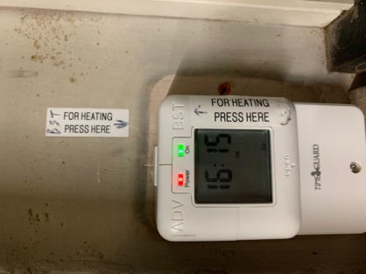
The heating control for the church is inside the Sacristy, to the left of the door as you enter.
The heating is boosted by pressing the button on the top right.
The heating is switched off by pressing the button on the top left.
Note that the fans within the heaters will continue to blow for a short while after switching off.

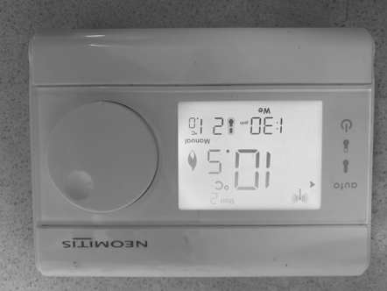
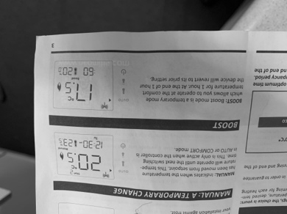
The heating control for the narthex is in the kitchen at the main door.
Check that the boiler switch is on, then turn the temperature wheel to 21 degrees.
To switch off, turn the temperature wheel to 0 degrees

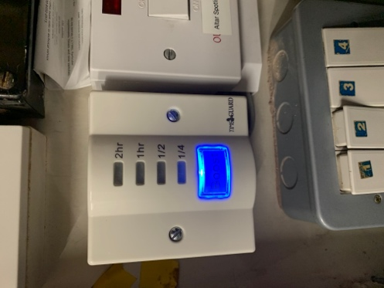
St Joseph car park lights

For evening services, the car park lights should be on while people are arriving and need to stay on until all Stewards have left.
The booster for the lights is in the Sacristy, to the left of the door as you enter.
Press the button repeatedly to increase the time the lights will be on.

St Godric’s
The heating control is behind the pulpit.
The heating is increased by turning the wheel to 21 degrees.
The heating is decreased by turning the wheel back to 16 degrees.
Please note that the main heating settings in the John Boste room must only be changed by a member of the Buildings and H&S committee.

